2022 is shaping up to be another interesting time for all of us, so let’s hope it’s interesting in a good way. As I’ve mentioned previously, we’re holding a general meeting of members on Wednesday 2nd March and, as per our tradition it will be an AGM and we will formally presenting the Co-op's financial report for 2020/2021. There is news on the proposed maintenance projects to be shared and an opportunity for you to share your views with all of your fellow co-op members. We will convey changes to the annual fees and present any Special Resolutions put forward by members. If you wish to put forward a Special Resolution for all members to consider and vote upon then please refer to the Rule 31, paragraph 2. All submissions welcomed.
The meeting will be conducted by Zoom video conference in a similar fashion to last year's meeting so please make yourself familiar with the technology. A formal Notice of Meeting will be forwarded to members at the appropriate time.
Nominations for board positions are sought as per Rule 47 paragraph 4.

Christmas Party

The Christmas Party was held on the 19th of December with 50 members turning up for the celebration. Thanks to Phil O’Leary and those who helped him set up. The event was catered for by Karin Slade, whose husband John (another proud Swanson owner) is a waitlisted member. In true PAC tradition those who attended cleared everything away in a matter of minutes after the show.
Pittwater Sailors honoured Ron and Marylin Baxter for their substantial and constant support spanning 25 years. Retiring Sailing Captain Noel Phelan presented a beautiful plaque to Ron and Marylin and announced the establishment of a Perpetual Trophy to be initiated by Pittwater Sailors.
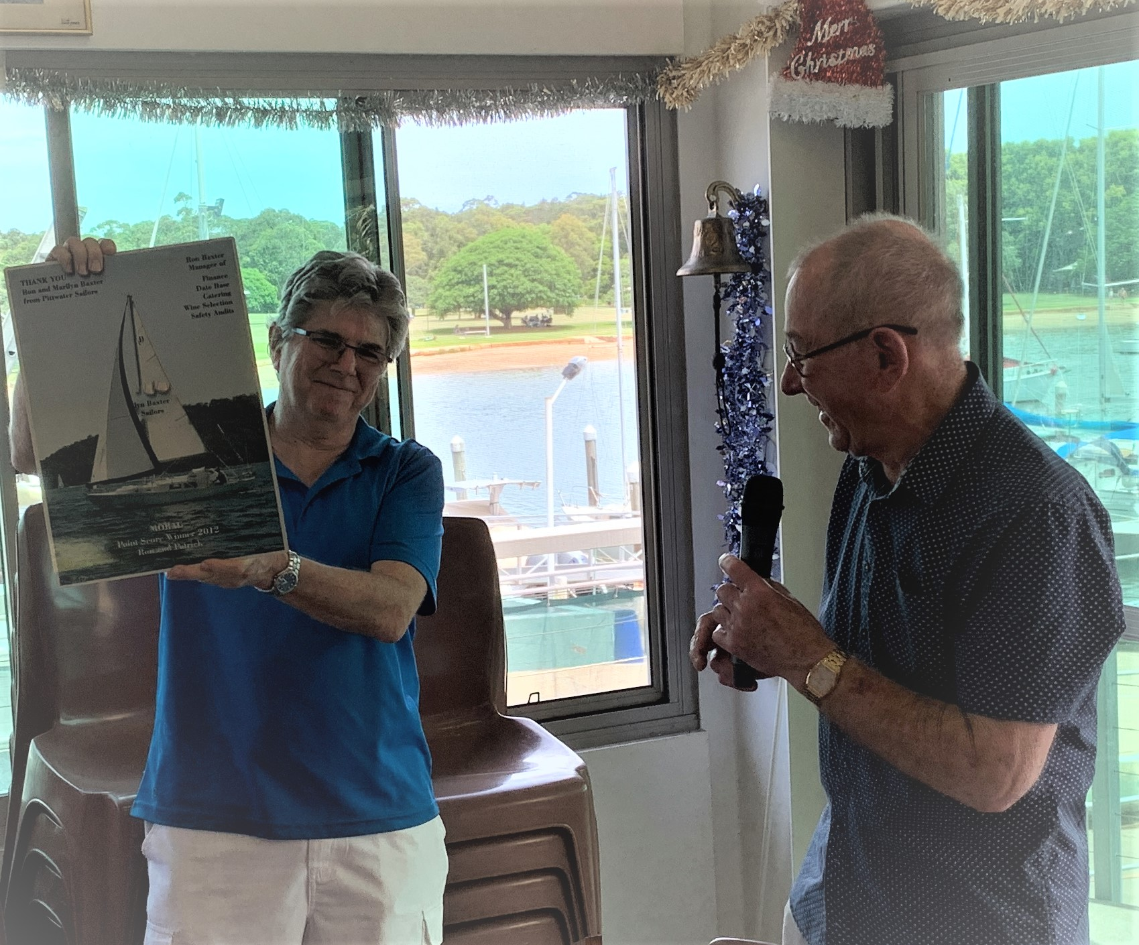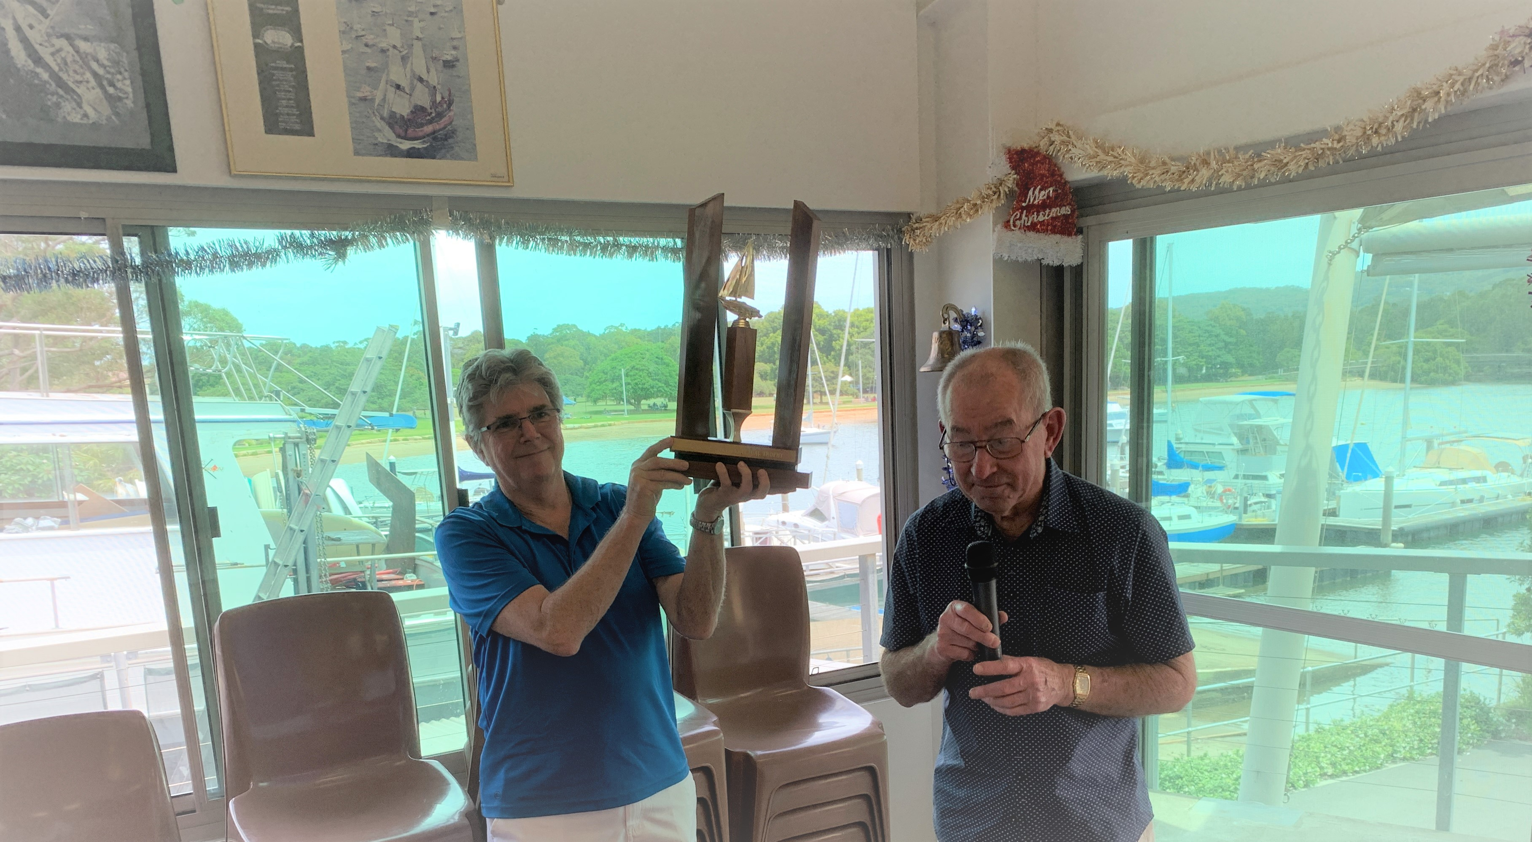
Noel is pictured on the right making the presentations

Safety Message
Slip, slop, slap and drink plenty (of water).

